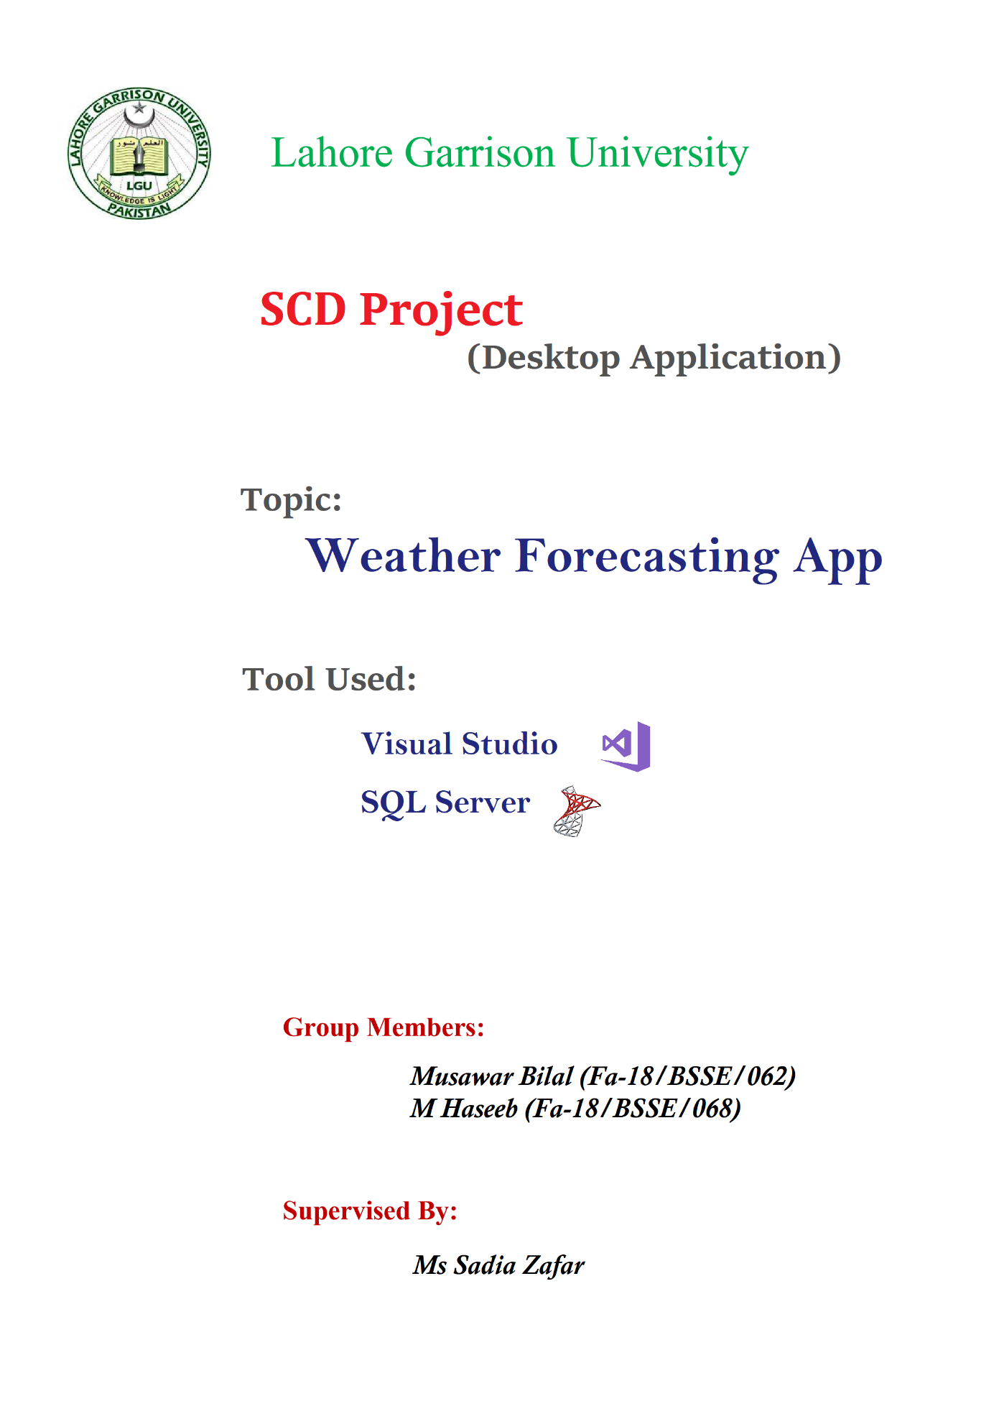

**Table of Contents: -**

1. Introduction ……….……………………………………………………………………Page 3

2. Overall Description……………………………………………………………………. Page 3

3. Functional/Non-functional Requirements ……………………………………………...Page 4

4. Project and Database Requirements…………………………………………………….Page 5

5. Project Prototype ………..………………………………………………………………Page 5

6. Mind Mapping …………...………………………………………………………………Page 7

7. Activity Diagram .………..………………………………………………………………Page 8

8. Sequence Diagram ……………………………………………………………………… Page 9

**Weather Forecasting Application (SRS Document)**

**Introduction:**

**Definition:** Weather forecasting is the application of science and technology to predict the conditions of the atmosphere for a given location and time. Weather forecasting is the application of science and technology to predict the conditions of the atmosphere for a given location and time. Weather forecasting desktop application is a platform where we can easily find the weather forecast report of almost every part of the country.

**Overview:** We have created a desktop weather forecasting application in which we can forecast the weather conditions of daily and the whole week record of different cities. There is an admin panel through which we can update data and view records stored in the database. The instructions for using the applications were also included.

**References:**

* <http://mazimbuweath.blogspot.com/2017/02/srs-assigment.html>
* https://en.wikipedia.org/wiki/Weather_forecasting

**Overall Description:**

**User Interface:** A first-time user of the Weather forecast should follow the instructions as given in the start of the application. Users can directly access the complete weather conditions of different cities on daily basis and weekly basis.

**Hardware Interface:** As it is a desktop application and running on a personal computer so we require a PC with good RAM, Storage and Operating system.

**Software Interface:** Software interface includes Microsoft Visual Studio 2017 with .NET Framework and Desktop Development with C# extensions for designing the interface and implementing queries on User controls and connecting database of SQL server. Software also includes Microsoft SQL Server for creating database and tables.

**Memory Constraints:** Weather App uses 86mb of the memory when it is being executed.

**Design Constraints**:

**Operations:** The weather desktop application is used to display the weather report of different cities daily and weekly weather conditions. It also enables login feature to admin and provide an admin panel through which admin can update and view records.

**User Characteristics:**

* Users will be provided with the quick instructions for using application.
* Users can get complete weather report of different cities.
* User will also get information about weekly weather.

**REQUIREMENTS:**

**Functional Requirement**

|  |  |
| --- | --- |
| Function 1 | Display Daily Weather |
| Input | Enter the name of City |
| Output | Record shown from Database |
| Processing | Validate the given details and Shows record from database |

|  |  |
| --- | --- |
| Function 2 | Display Weekly Weather |
| Input | Click the button Check Weekly forecasting. |
| Output | Database Record |
| Processing | Validate the given details and record the information in to the database. |

|  |  |
| --- | --- |
| Function 3 | Admin Login |
| Input | Enter Username and Password |
| Output | Shows the Admin panel |
| Processing | Check whether the Username and password are correct. |

|  |  |
| --- | --- |
| Function 4 | Admin can Update Record |
| Input | Enter the name of city and new values in textboxes then click update |
| Output | Shows the Message box of Success |
| Processing | Search for the name of specified city and change the values of the entry. |

|  |  |
| --- | --- |
| Function 5 | Admin can View Record |
| Input | Enter the Record button |
| Output | Shows the Record in Data grid |
| Processing | Shows the data record of the table specified in data grid. |

**NON-Functional Requirement:**

* Instructions to use Application
* Photo Gallery
* Icon Buttons
* User Friendly
* Maintenance

**Project and Database Requirements:**

**Update:**

* Select update record from admin panel.
* Enter the city name of which you want to update data.
* Enter the new values in the textboxes.
* After the data entered, click **Update** button.
* Message box will be shown on the screen data updated successfully.

**View:**

* Select View Record from admin panel.
* Enter the Record button.
* All the data in the specified table will be shown in data grid.

**Search:**

* Enter the City Name.
* Click Search.

**Project Prototype:**

**Total Forms:**

8 User Controls in this project

1. Start Page
2. Steps to Use Application
3. Daily Weather
4. Weekly Weather
5. Admin Login Page
6. Admin Panel
7. Admin Update Record
8. Admin View Record

**Total DataBases:**

We have used only one database in our project **weather_test**.

**Total Tables**

We have used 2 tables in our project

1. Dailyweather_table 2. Weeklyweather_table

**Total Buttons :**

1. Start (Button)
2. NEXT (Button)
3. SKIP (Button)
4. Search (Button)
5. Check Weekly Forecast (Icon Button)
6. Check Daily Forecast (Icon Button)
7. Sign In (Button)
8. View Record (Button)
9. Update Record (Button)
10. Update (Button)
11. Record (Button)
12. Cancel (Button)
13. Back (Icon Button)

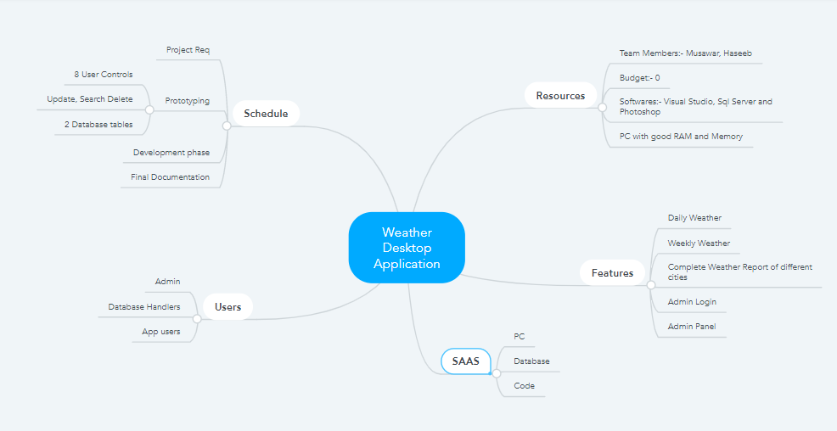**Mind Mapping:**

**Activity Diagram:**

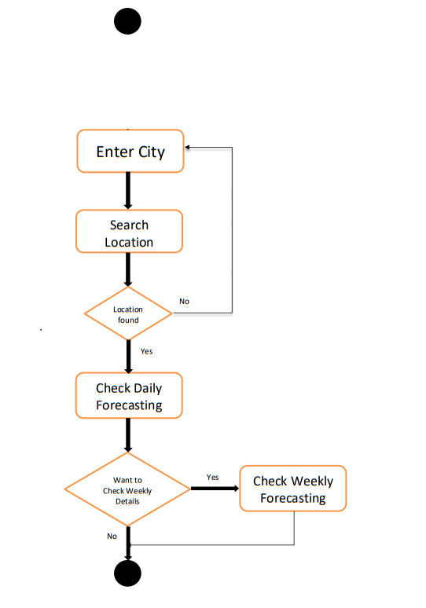

Yes

Admin

**View Record**

**Update Record**

**Admin Panel**

**Sequence Diagram:**

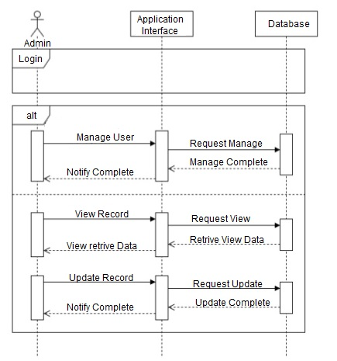

**The End**